# **Azure storage documentation**

1. Introduction to the core Azure Storage services
2. Types of storage accounts
3. Create a Storage account
4. Learn about Data redundancy

**Introduction to the core Azure Storage Services:**

The Azure Storage platform is Microsoft's cloud storage solution for modern data storage scenarios. Core storage services offer a massively scalable object store for data objects, disk storage for Azure virtual machines (VMs), a file system service for the cloud, a messaging store for reliable messaging, and a NoSQL store.

## **Core storage services**

The Azure Storage platform includes the following data services:

* Azure Blobs: A massively scalable object store for text and binary data. Also includes support for big data analytics through Data Lake Storage Gen2.
* Azure Files: Managed file shares for cloud or on-premises deployments.
* Azure Queues: A messaging store for reliable messaging between application components.
* Azure Tables: A NoSQL store for schemaless storage of structured data.
* Azure Disks: Block-level storage volumes for Azure VMs.

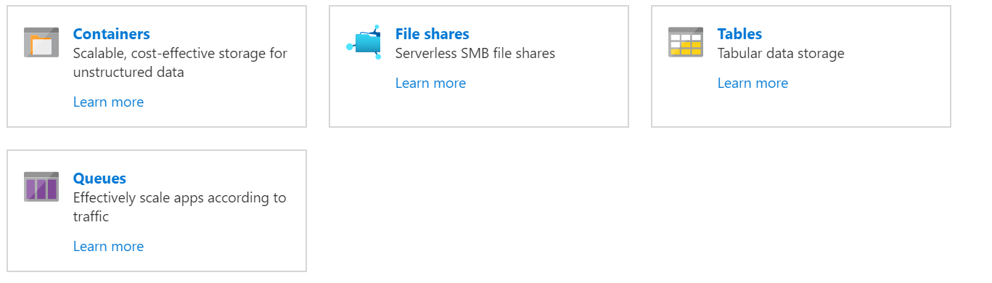

## **Example scenarios**

The following table compares Files, Blobs, Disks, Queues, and Tables, and shows example scenarios for each.

|  |  |  |
| --- | --- | --- |
| **Feature** | **Description** | **When to use** |
| Azure Files | Offers fully managed cloud file shares that you can access from anywhere via the industry standard Server Message Block (SMB) protocol.  You can mount Azure file shares from cloud or on-premises deployments of Windows, Linux, and macOS. | You want to "lift and shift" an application to the cloud that already uses the native file system APIs to share data between it and other applications running in Azure.  You want to replace or supplement on-premises file servers or NAS devices.  You want to store development and debugging tools that need to be accessed from many virtual machines. |
| Azure Blobs | Allows unstructured data to be stored and accessed at a massive scale in block blobs.  Also supports [Azure Data Lake Storage Gen2](https://docs.microsoft.com/en-us/azure/storage/blobs/data-lake-storage-introduction) for enterprise big data analytics solutions. | You want your application to support streaming and random access scenarios.  You want to be able to access application data from anywhere.  You want to build an enterprise data lake on Azure and perform big data analytics. |
| Azure Disks | Allows data to be persistently stored and accessed from an attached virtual hard disk. | You want to "lift and shift" applications that use native file system APIs to read and write data to persistent disks.  You want to store data that is not required to be accessed from outside the virtual machine to which the disk is attached. |
| Azure Queues | Allows for asynchronous message queueing between application components. | You want to decouple application components and use asynchronous messaging to communicate between them |
| Azure Tables | Allow you to store structured NoSQL data in the cloud, providing a key/attribute store with a schemaless design. | You want to store flexible datasets like user data for web applications, address books, device information, or other types of metadata your service requires. |

## **Types of storage accounts**

## Azure Storage offers several types of storage accounts. Each type supports different features and has its own pricing model. Consider these differences before you create a storage account to determine the type of account that is best for your applications. The types of storage accounts are:

* General-purpose v2 accounts: Basic storage account type for blobs, files, queues, and tables. Recommended for most scenarios using Azure Storage.
* General-purpose v1 accounts: Legacy account type for blobs, files, queues, and tables. Use general-purpose v2 accounts instead when possible.
* BlockBlobStorage accounts: Storage accounts with premium performance characteristics for block blobs and append blobs. Recommended for scenarios with high transactions rates, or scenarios that use smaller objects or require consistently low storage latency.
* FileStorage accounts: Files-only storage accounts with premium performance characteristics. Recommended for enterprise or high performance scale applications.
* BlobStorage accounts: Legacy Blob-only storage accounts. Use general-purpose v2 accounts instead when possible.

**Standard:** ​

* Backed by magnetic drives (HDD)​
* Lowest cost per GB​

**Premium:​**

* Backed by solid-state drives (SSD)​
* Can only be used with Azure VM disks​

You can easily upgrade a general-purpose v1 or Blob storage account to a general-purpose v2 account with no downtime and without the need to copy data​

# **Create an Azure Storage account**

To create a general-purpose v2 storage account in the Azure portal, follow these steps:

1. On the Azure portal menu, select All services. In the list of resources, type Storage Accounts. As you begin typing, the list filters based on your input. Select Storage Accounts.
2. On the Storage Accounts window that appears, choose Add.
3. Select the subscription in which to create the storage account.
4. Under the Resource group field, you can select the existing Resource Group or select Create new. 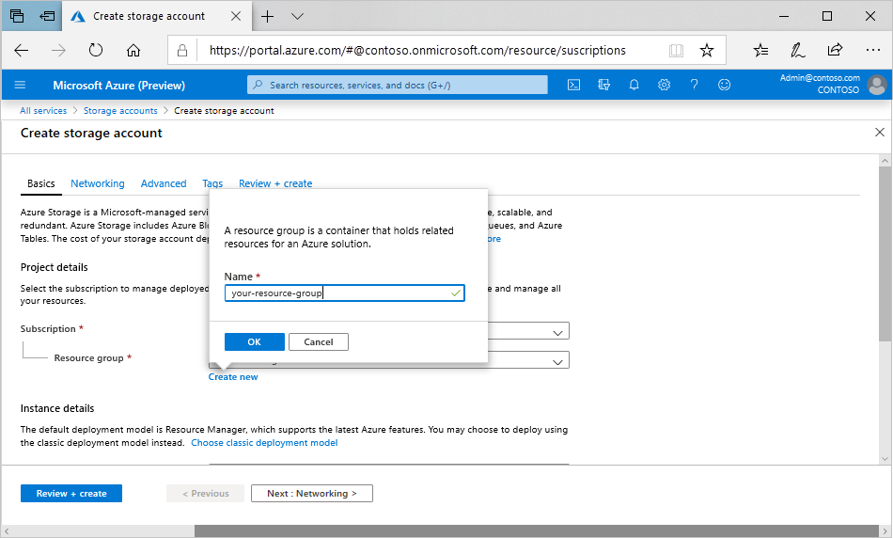
5. Next, enter a name for your storage account. The name you choose must be unique across Azure. The name also must be between 3 and 24 characters in length, and can include numbers and lowercase letters only.

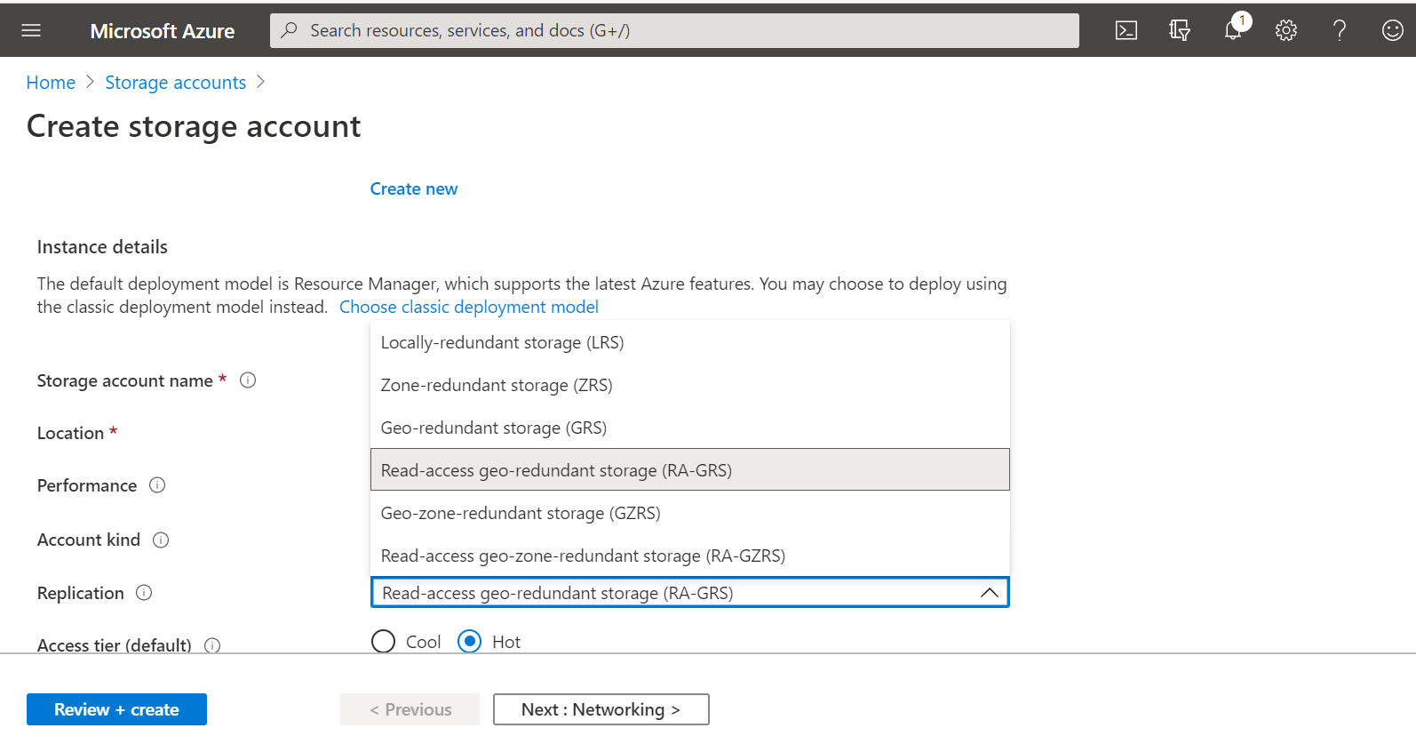

1. Select a location for your storage account, or use the default location.
2. If you plan to use Azure Data Lake Storage, choose the Advanced tab, and then set Hierarchical namespace to Enabled.
3. Select Review + Create to review your storage account settings and create the account.
4. Select Create.

**Storage Account Replication**

Storage account replication is about protecting your data from unplanned events like hardware failures, network outages, and even natural disasters.

How you choose to replicate your data also impacts the service level agreement for storage. Your data is always replicated in the primary data center. You can just expand on that with other options.

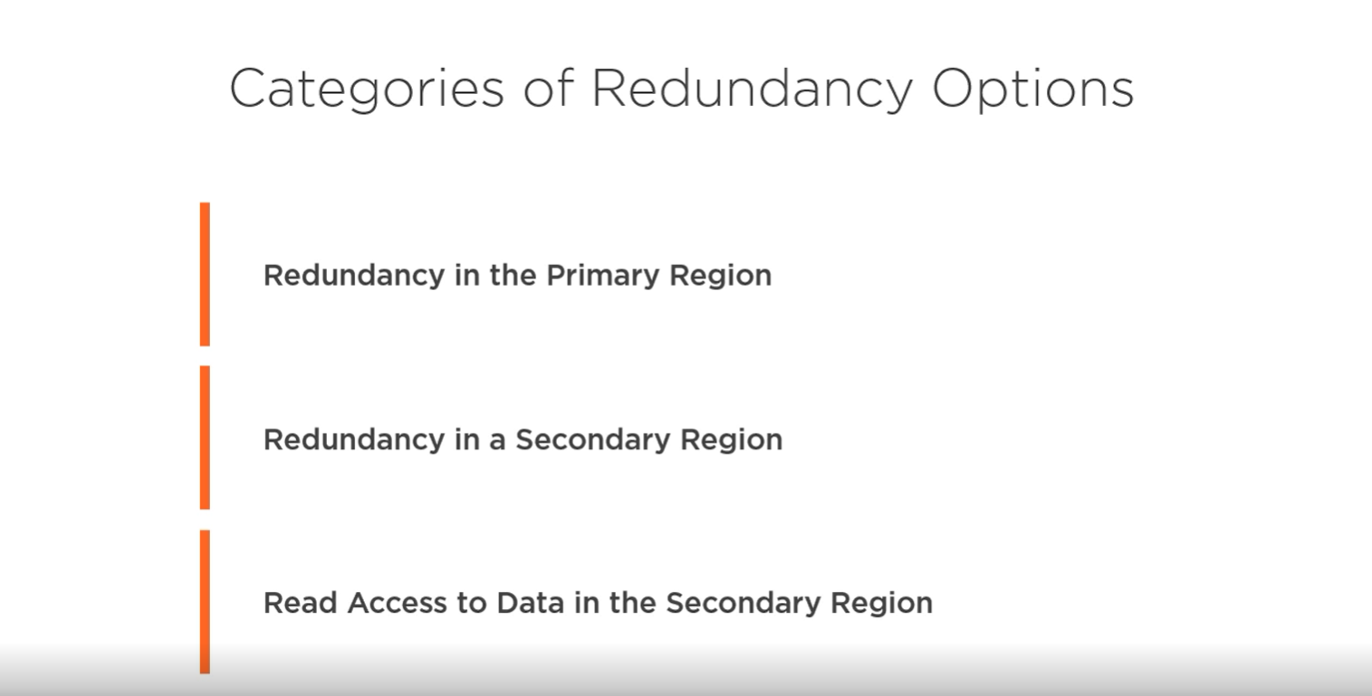There are three categories that group the replication options, redundancy in the primary region, redundancy in a secondary region, and read access to data in the secondary region.

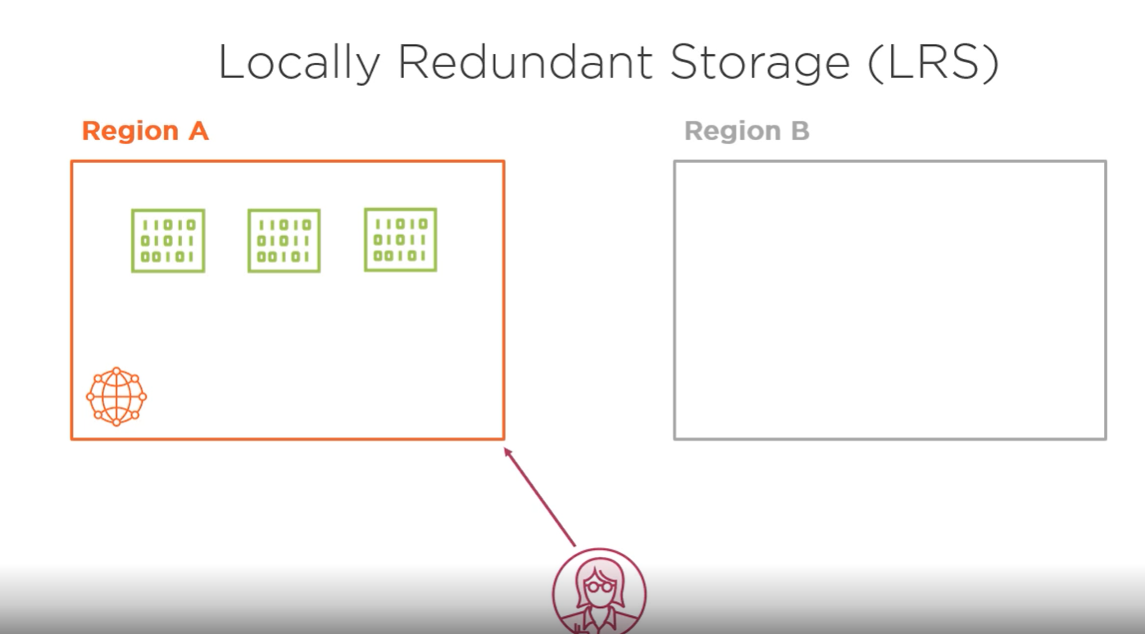

Let's start with the primary region options. Locally redundant storage is the lowest‑cost replication option. Your data is replicated within a collection of racks of storage nodes within a single data center in the region that you choose when you create your storage account. This is called a storage scale unit. Your data is spread across multiple hardware racks, so it's still available when a hardware failure impacts a single rack. But because all the data is within a single data center, there's still the risk of a data center‑level disaster, like a fire or flooding. To help mitigate the risk, the next storage account type is zone‑redundant storage.

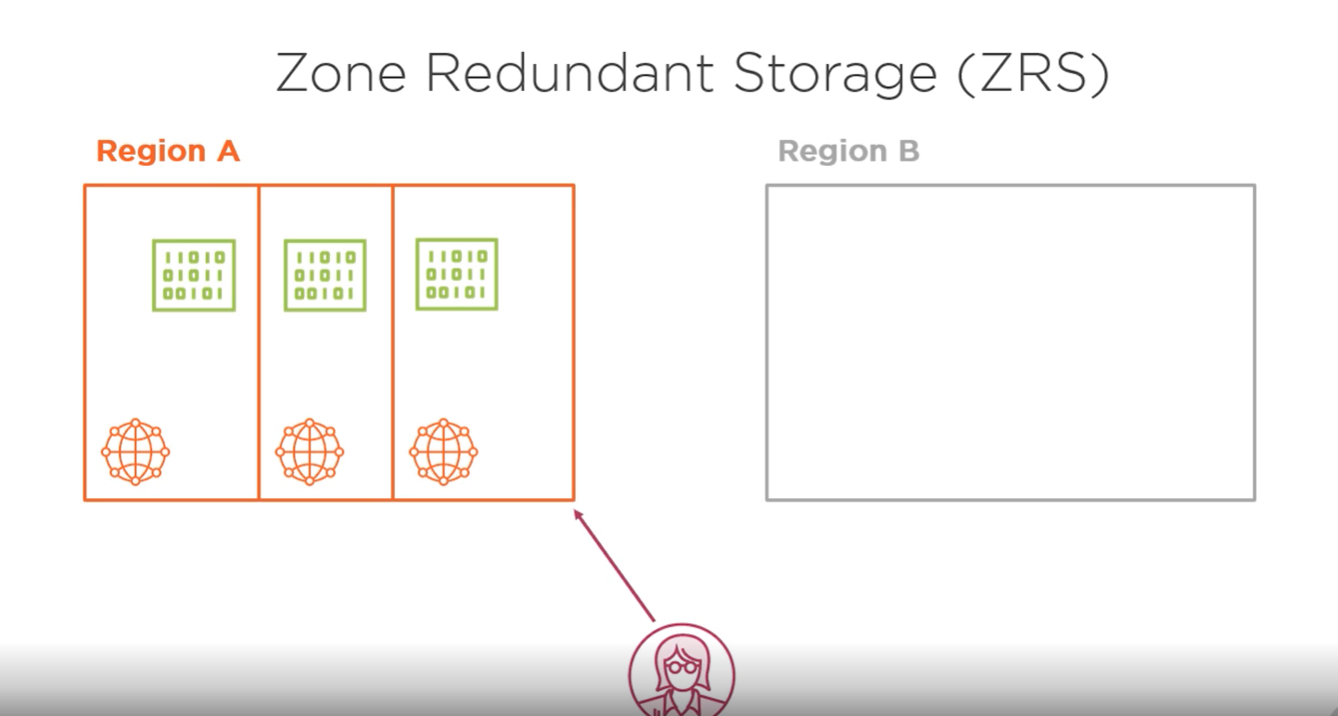

This storage replicates your data across three storage clusters in a single region. Each cluster is physically separate in what's called an availability zone, with its own separate utilities and networking.

Zone‑redundant storage isn't available in every Azure region, and depending on the service and region, not all storage services may be available. When you create a new storage account and choose a region, you'll be able to see if zone‑redundant storage is available to you. So locally redundant storage and zone‑redundant storage provide redundancy in the primary Azure region your storage account is located in.

Now let's talk about the options that provide redundancy in a secondary region. There are two options available, geo‑redundant storage and geo‑zone‑redundant storage.

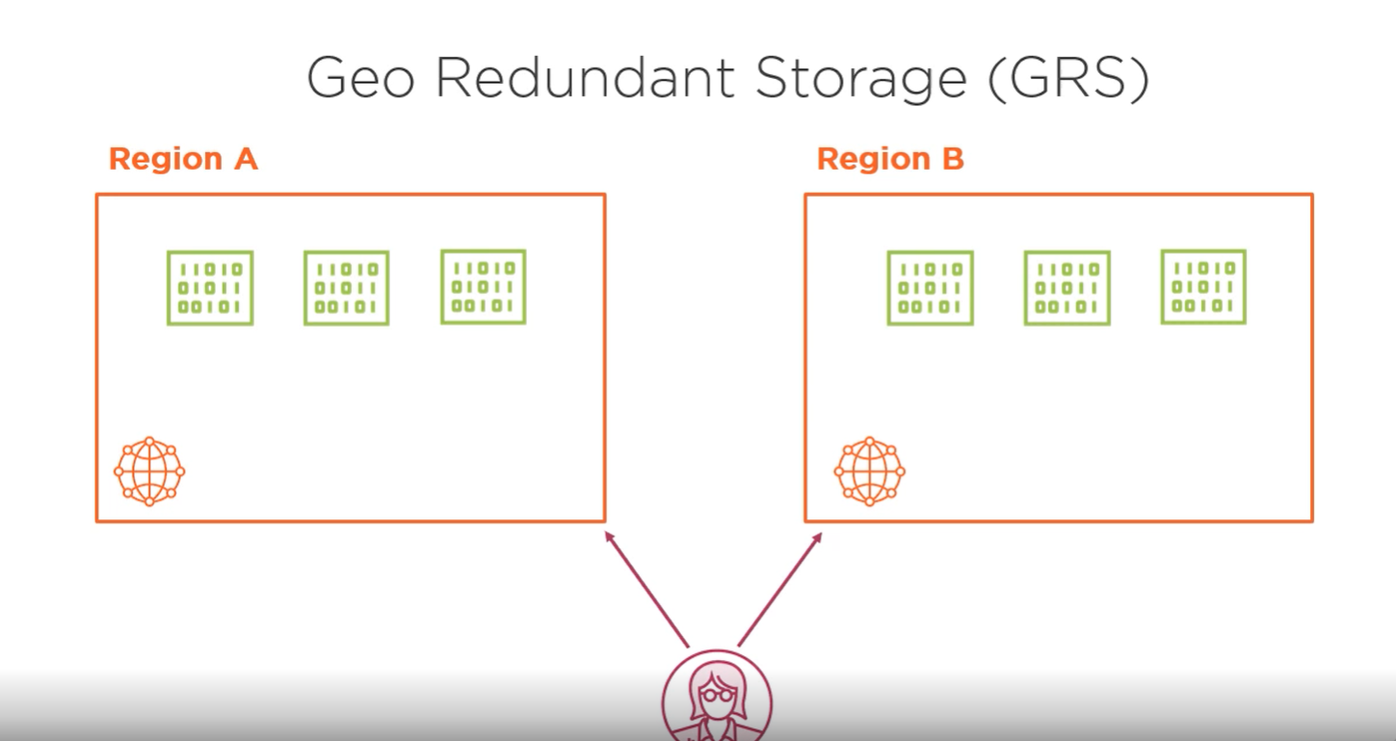

Geo‑redundant storage copies your data three times in the primary region and also copies the data asynchronously to a single location in a secondary region. The data is copied three times in the secondary data center. It's basically locally redundant storage in two regions. The location of the secondary region is decided by Microsoft, and you can't change that. But it's selected to be hundreds of miles away from the primary region to prevent data loss in the event of a natural disaster. Paired regions are often within the same country. For example, East US and West US or Canada Central and Canada East. Microsoft lists the paired regions on their website if you're interested in checking, possibly out of concerns about data residency compliance that your organization might be bound to.

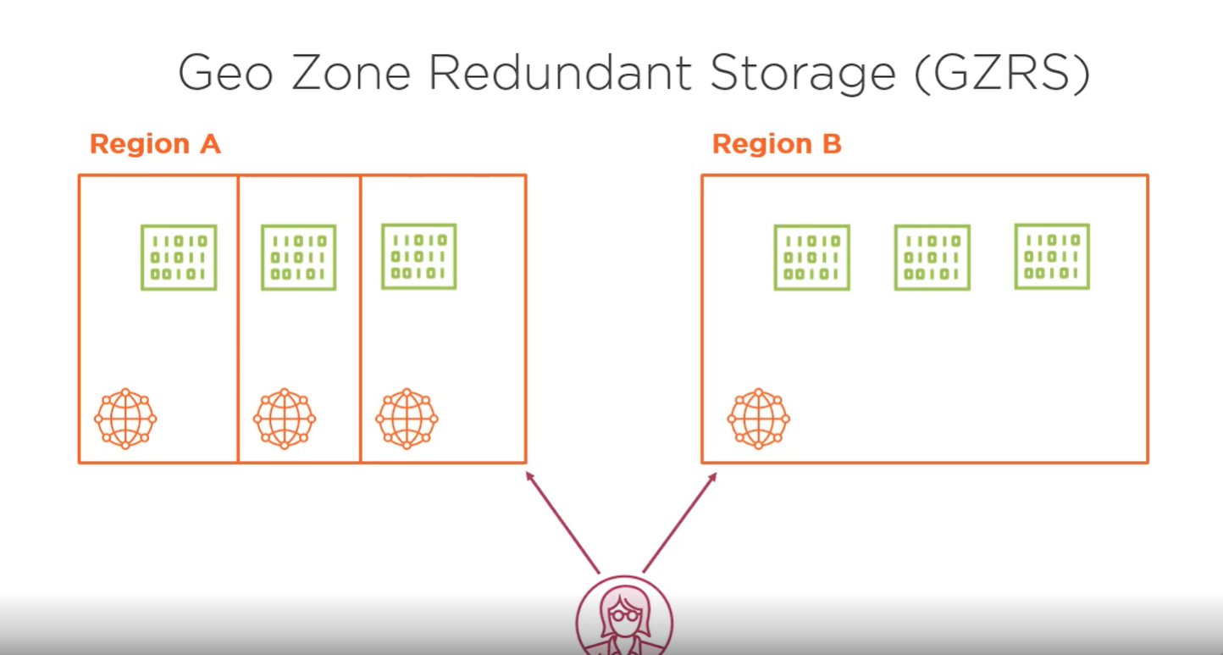

The second option for redundancy in a secondary region is geo‑zone‑redundant storage. This replication option uses zone‑redundant storage in the primary data center and locally redundant storage in a secondary data center. The geo‑zone‑redundant option requires you to use a GPv2 storage account type. With geo‑redundant and geo‑zone‑redundant storage, the data in the secondary region is only available to be read if you or Microsoft initiates a failover from the primary region to the secondary.

You might want to always have the ability for your application to read the data in the secondary region. You might do this so your application automatically fails over to the secondary region without waiting for the service to notice a problem, or you might just want more control over reads for performance reasons.

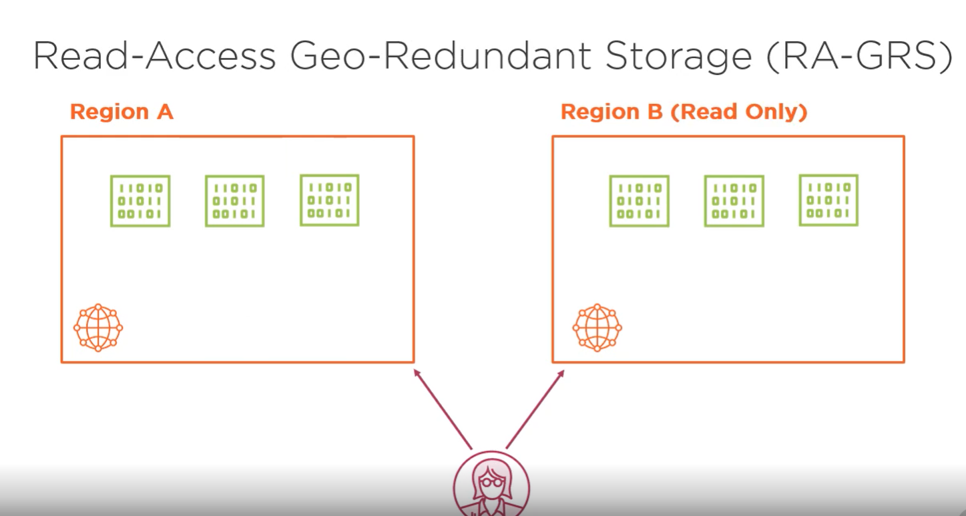

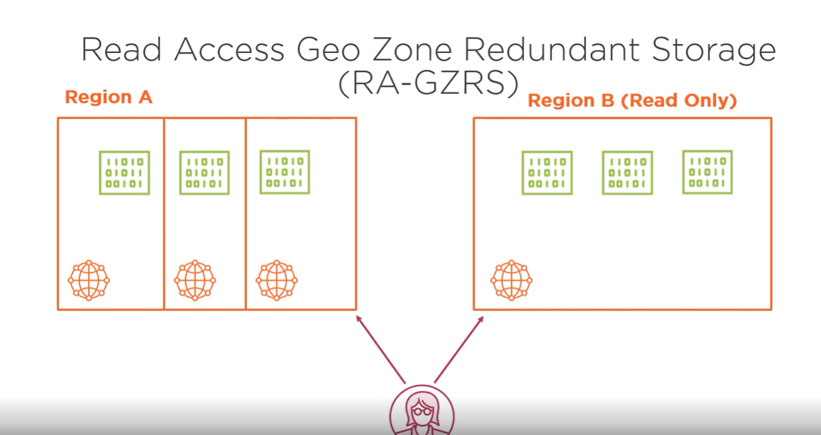

To enable this, there are two other replication options, read‑access geo‑redundant storage and read‑access geo‑zone‑redundant storage. The two options are similar to the previous versions that we discussed, geo‑redundant and geo‑zone‑redundant storage. They just add the ability to always be able to read data from the secondary region. The replication options available depend on which storage account type you select. And just like you saw in the clip on choosing a storage account type, the GPv2 type offers the most options. For the Premium storage account types, Azure Premium file storage currently only supports locally redundant storage, and block blob storage accounts support locally redundant storage, and in some regions, zone‑redundant storage is also available. Now that you understand the different features and options when creating a storage account, let's create a storage account using the Azure portal

